**My Blog, My Philippines**

**In Pictures – Part IV/D**

**By Alex Moises / Philippines, 2011-2012 Version / Dedicated to Gabby Moises**

**<People (PE), Places (PL), Nature (N), Animals (A), And Then Some (S) /**

**(Photo Arrangement - Left to Right, Top to Bottom for Each Page)**

Topic Highlight - Nature (N)

**Philippine Animals**

**Brahminy Kite**

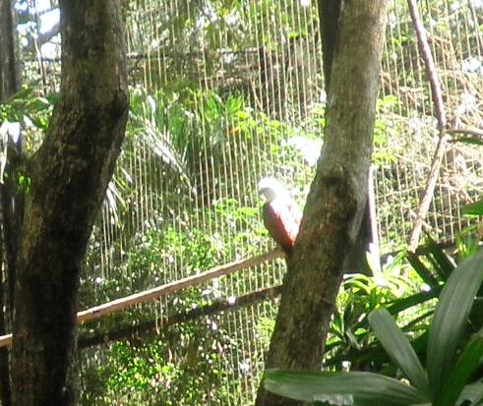 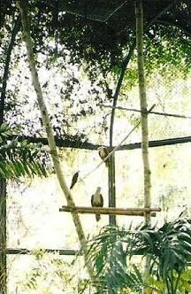

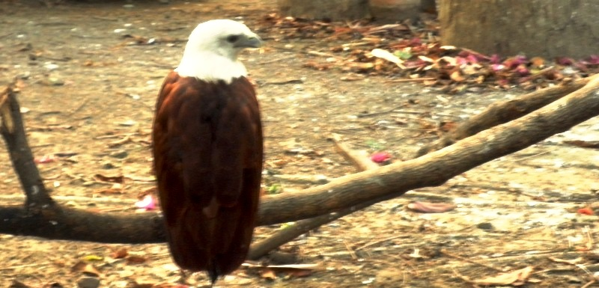

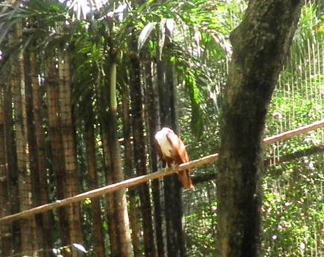

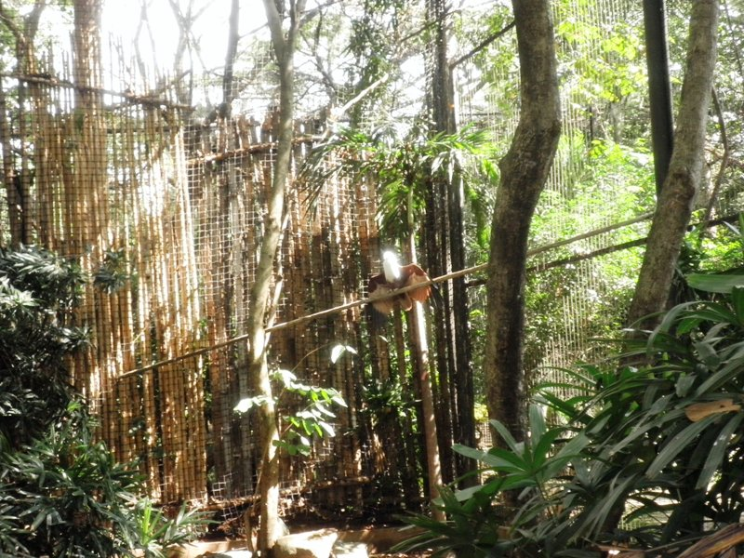

**Crested Serpent Eagle**

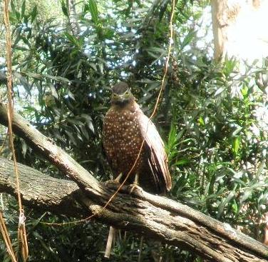

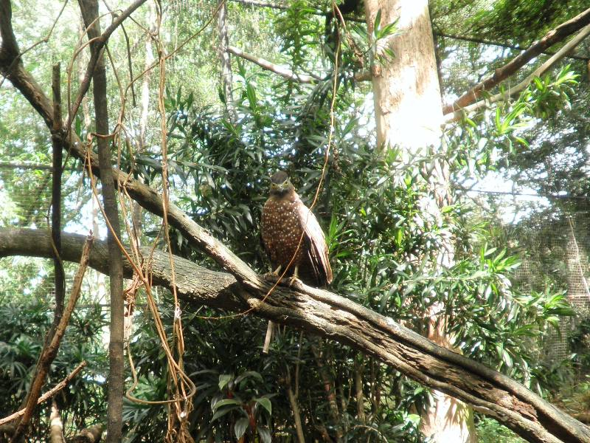

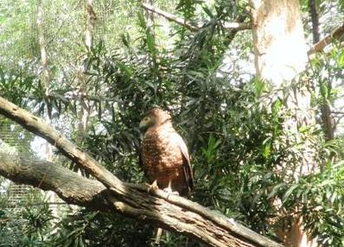

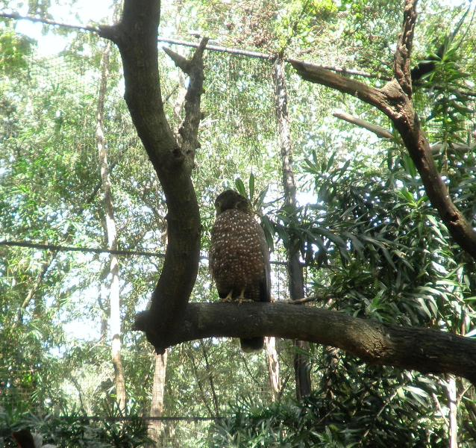

**Long-Tailed Macaque**

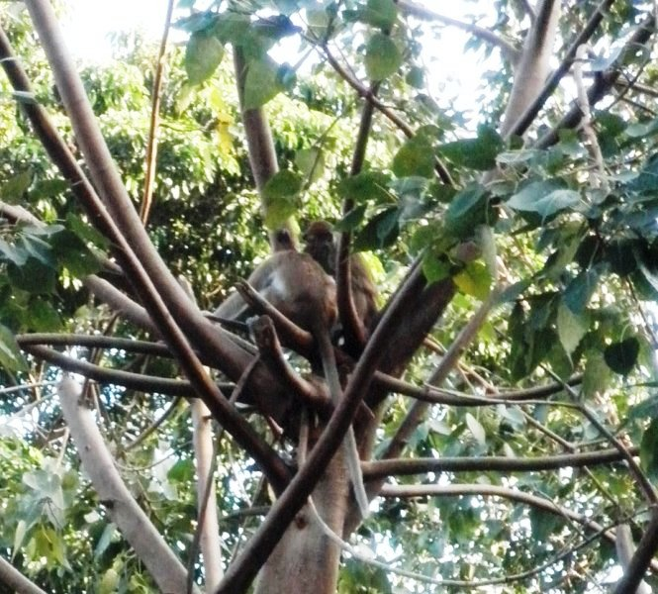

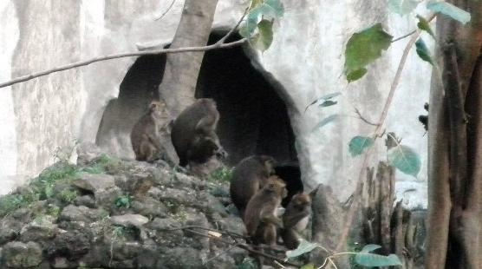

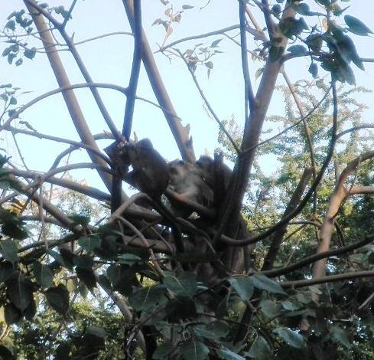

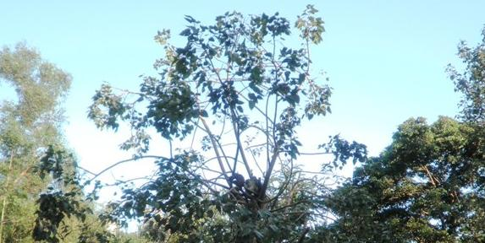

**Philippine Brown Deer**

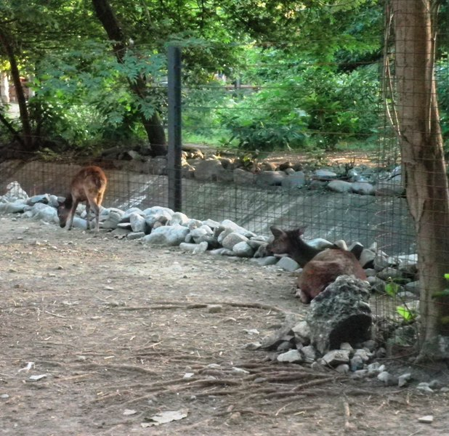

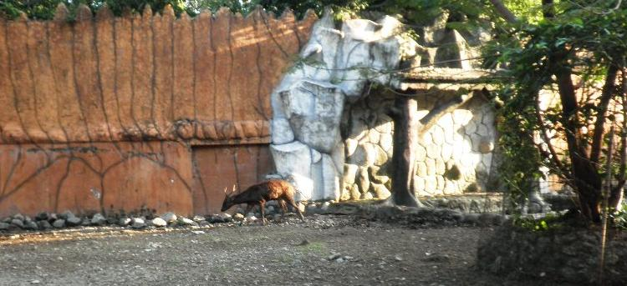

**Philippine** **Eagle**

(Photo Contributor: Photos Courtesy of the Philippine Eagle Foundation)

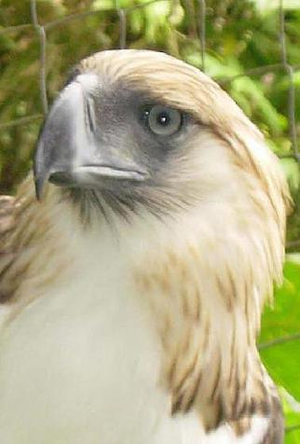 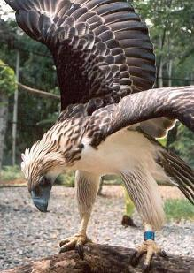

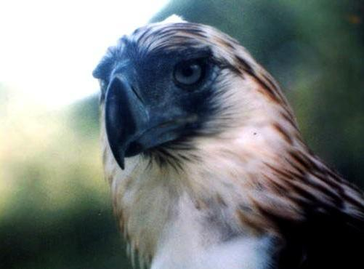

**Philippine** **Tarsier**

(Photo Contributor: Bottom Tarsier Photo in the Public Domain, Courtesy of Greek Golangco)

