My Blog, My Philippines
In Pictures – Part III
By Alex Moises / Philippines, 2010-2011 Version / Dedicated to Gabby Moises
<People (PE), Places (PL), Nature (N), Animals (A), And Then Some (S) /
(Photo Arrangement - Left to Right, Top to Bottom for Each Page)

People (PE) - Filipinos

Carlos P. Romulo, Diosdado Macapagal, Emilio Aguinaldo and Freddie Aguilar
(Photo Contributors: Romulo’s Photo, Courtesy of the Biographical Directory of the United States
Congress through Wikipedia's Public Domain Photos / Macapagal’s Photo, Courtesy of “philippinepresidency” on Flickr / Aguinaldo’s Photo in the Public Domain via Wikipedia /
Aguilar’s Photo, Courtesy of “ballyshannon's photostream” on Flickr via
Wikipedia’s Creative Commons)

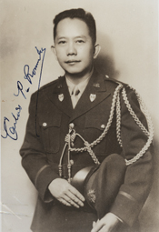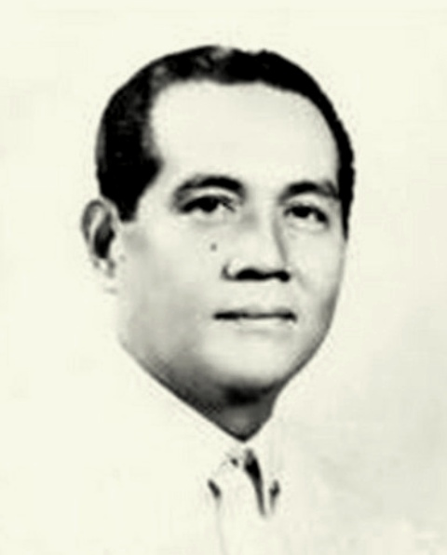

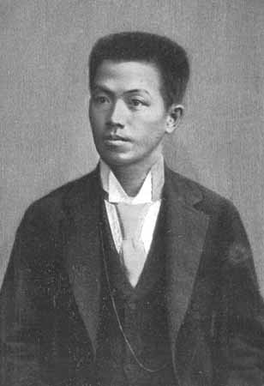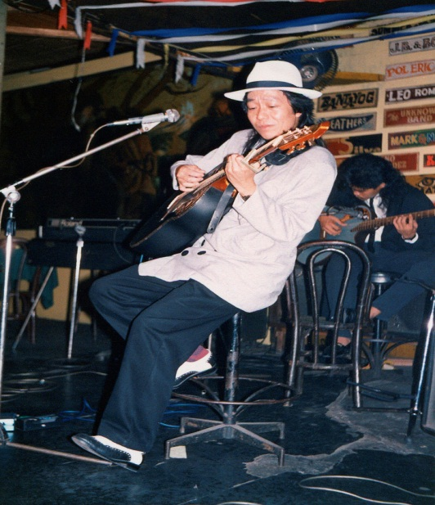

Loren Legarda, Manny Pacquiao, Manuel Villar and Ramon Magsaysay
(Photo Contributors: Legarda’s Photo in the Public Domain, Courtesy of the US Embassy in Manila via Wikipedia / Pacquiao’s Photo, Courtesy of Wikipedia’s Creative Commons / Villar’s Photo, Courtesy of www.louiephotography.philwired.net on Flickr via Wikipedia / Magsaysay’s Photo, Courtesy of pinoyvote.net via Wikipedia)

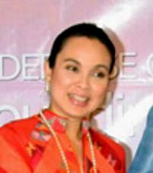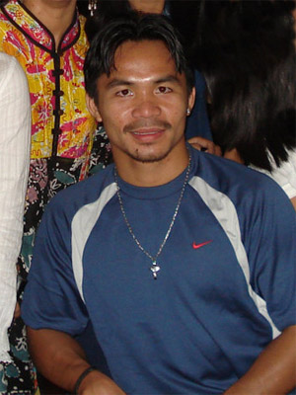

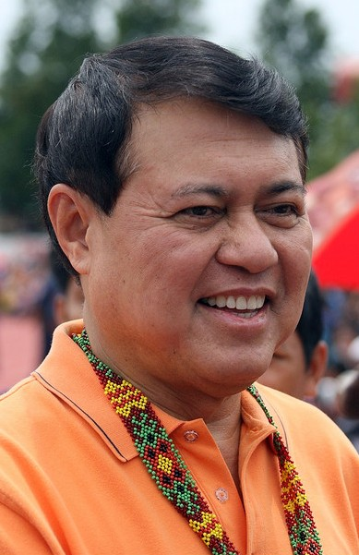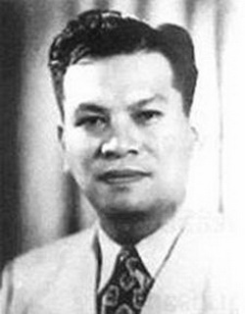

Places (PL) - Manila and Quezon City

Manila
(Location: Fort Bonifacio)

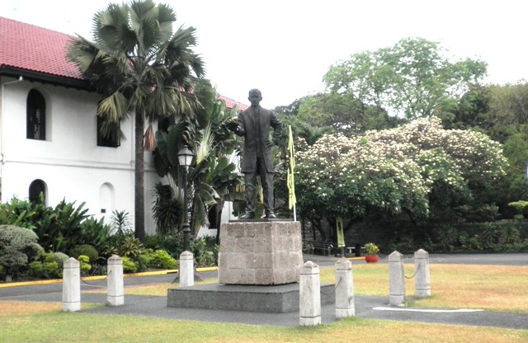

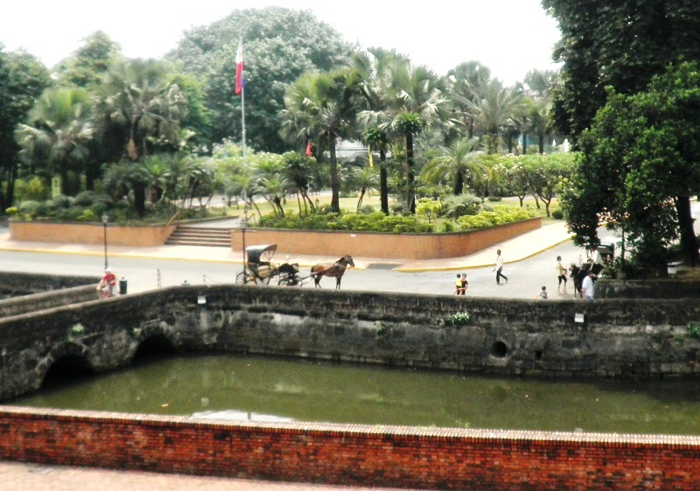

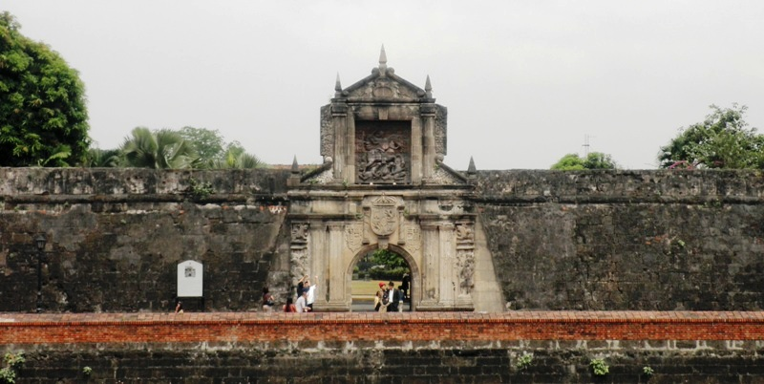

Manila
(Location: Rizal Park)

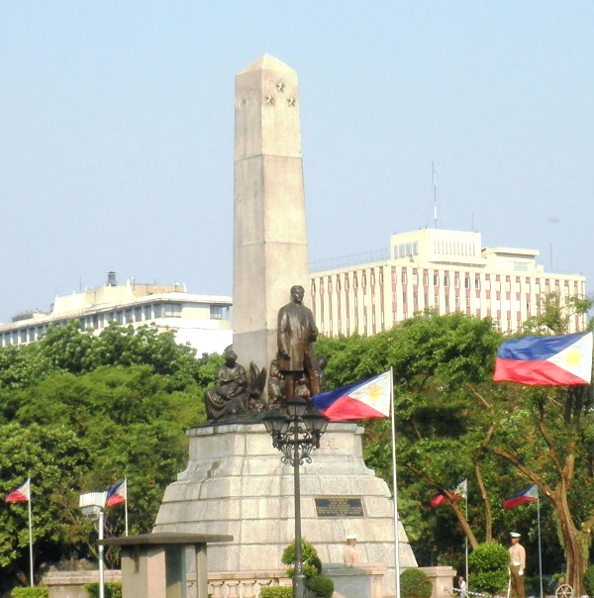

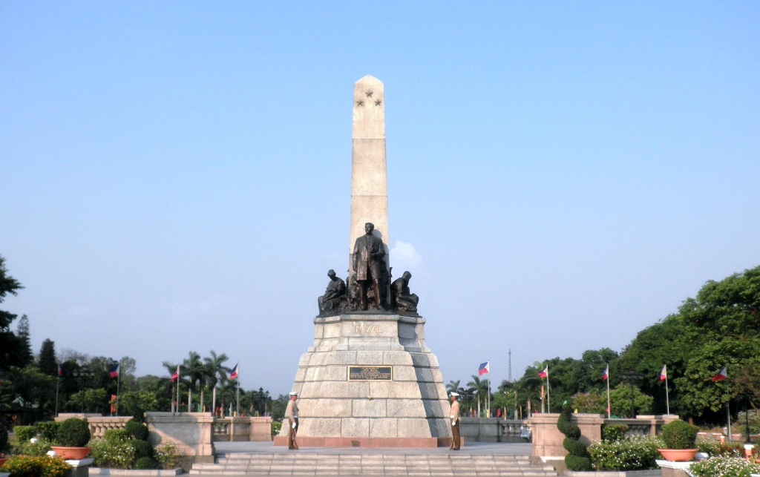

Manila
(Locations: Lawton or Liwasang Bonifacio <Top Two Photos> / Buildings along Pasig River / Roxas Boulevard <Next Pair Photos> / Manila Bay)

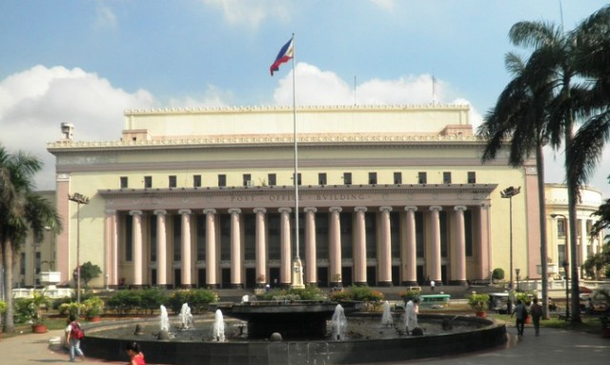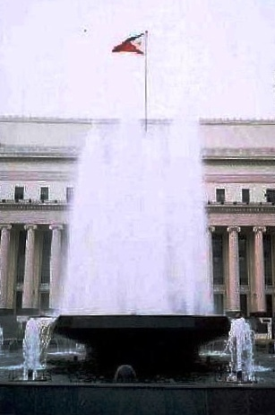

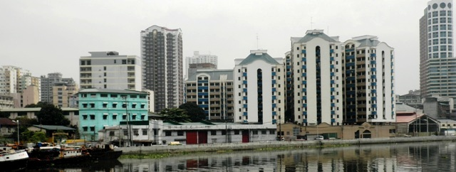

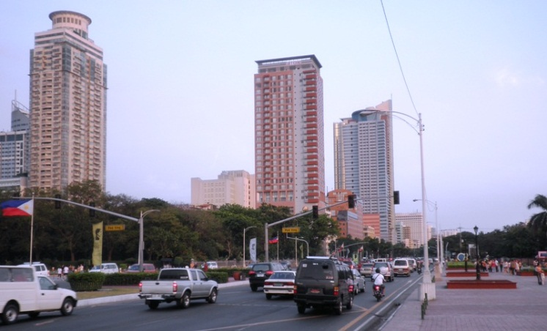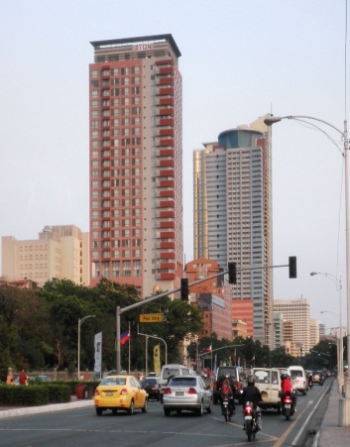

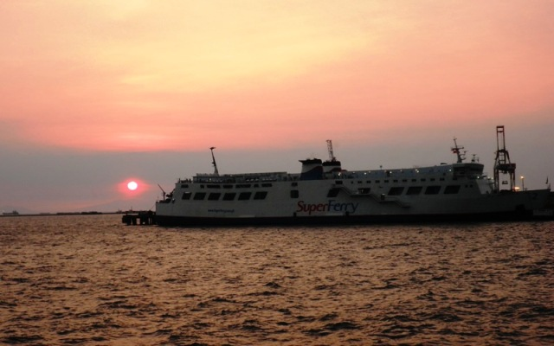

Quezon City
(Location: Araneta Center, Cubao)

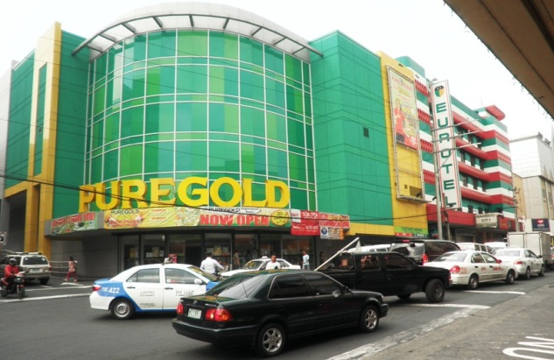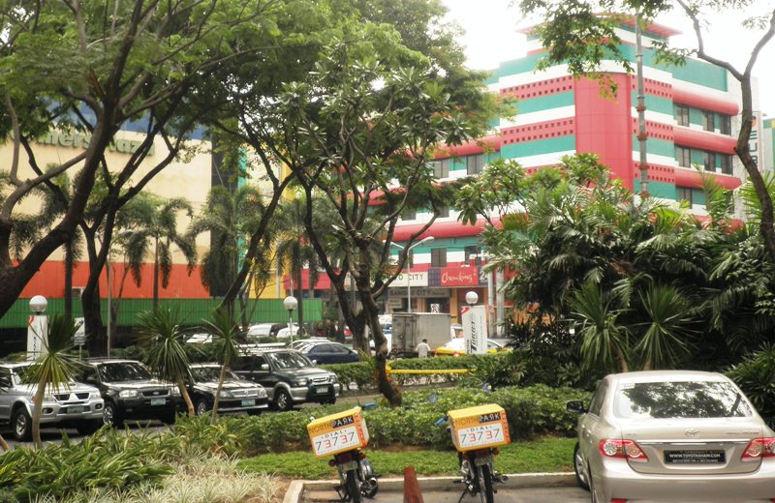

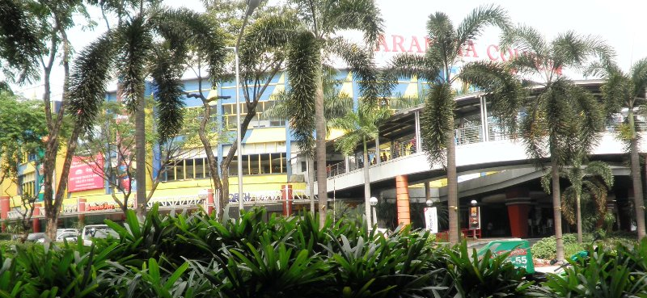

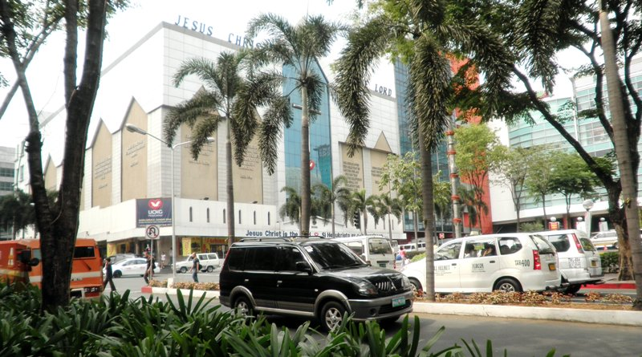

Quezon City
(Location: Farmer’s Plaza, Araneta Center, Cubao)

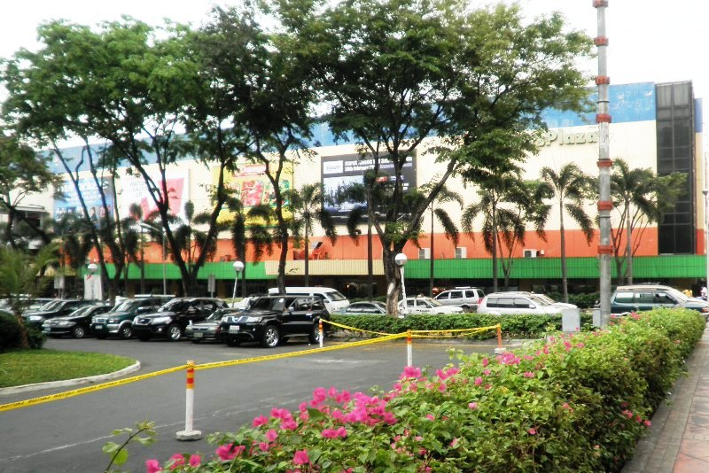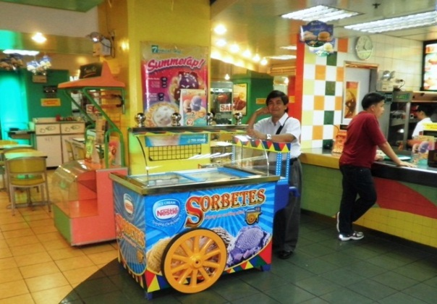

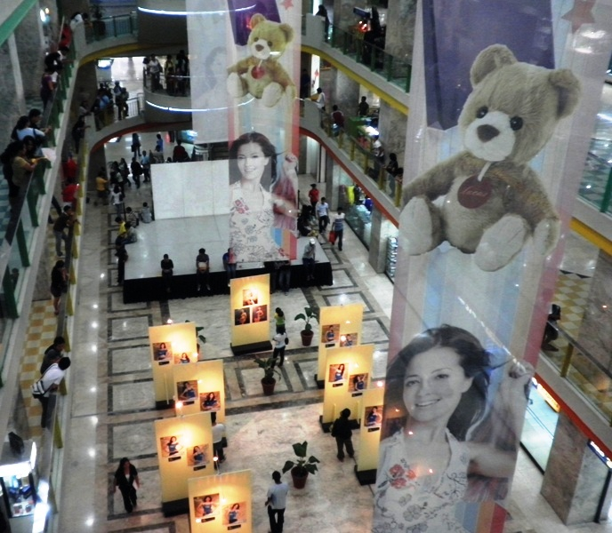

Quezon City
(Locations: Manuel L. Quezon Monument in front of Quezon City Hall and Jose Rizal Monument at Left Side facing the City Hall)

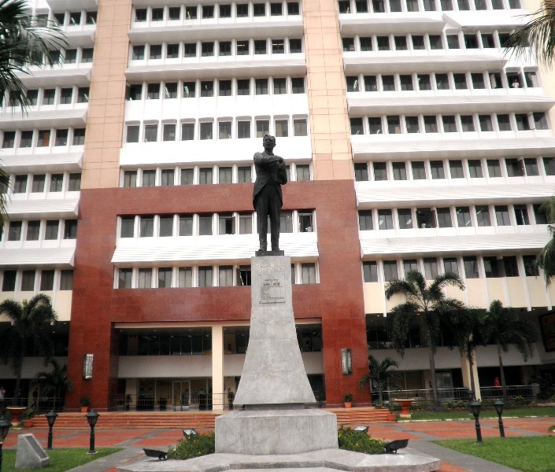

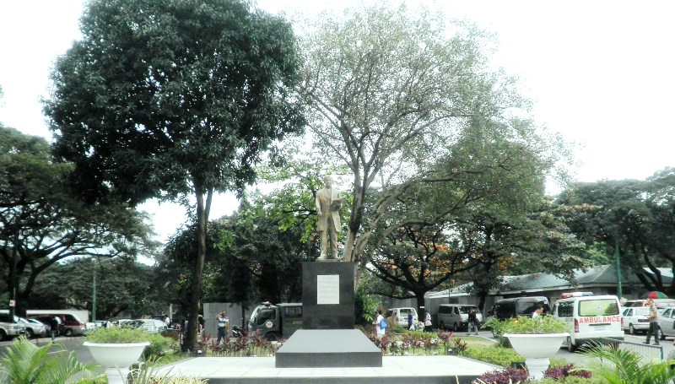

Quezon City
(Locations: EDSA near North and West Avenues / EDSA Cubao Underpass / EDSA Santolan / Note: EDSA - Epifanio de los Santos Avenue)

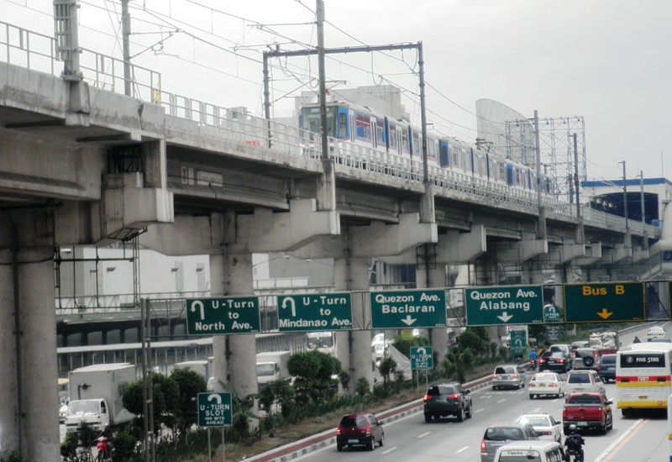

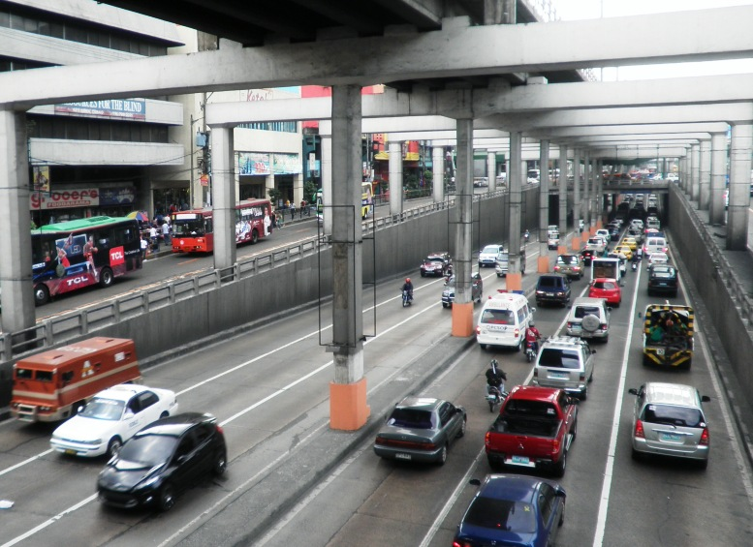

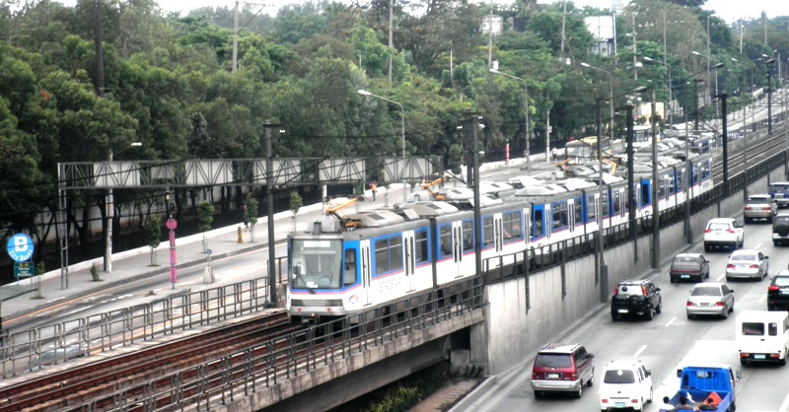

Quezon City
(Location: SM City, North Avenue and EDSA)

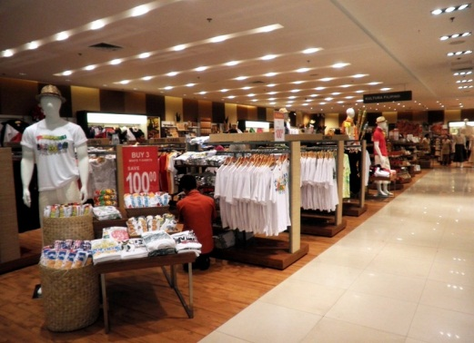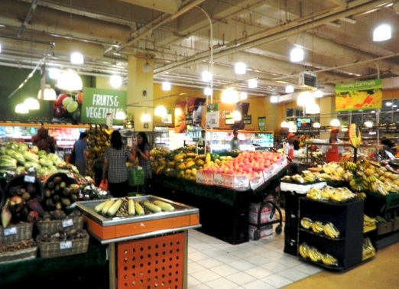

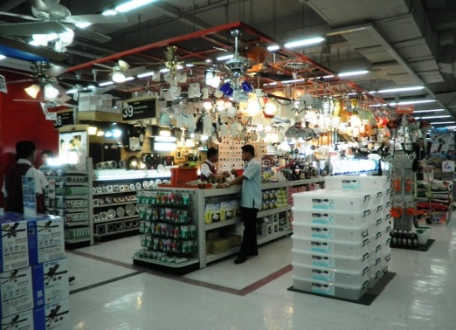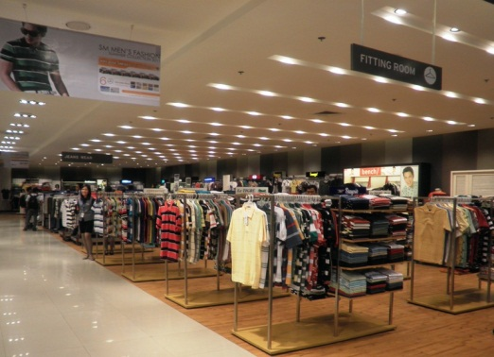

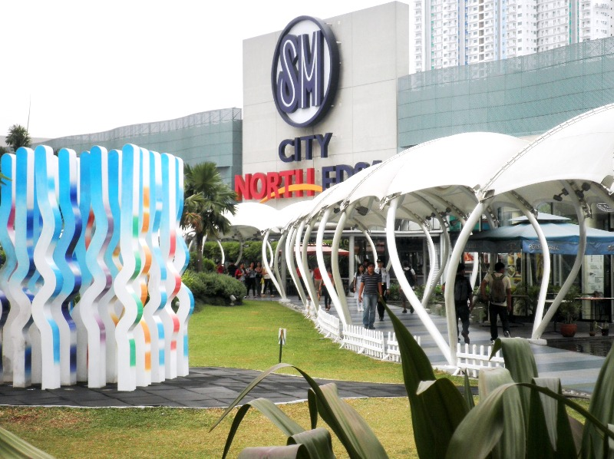

Nature (N) - Flowers

Gumamela - Hibiscus

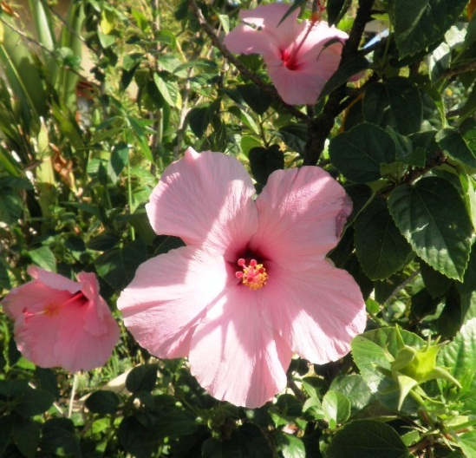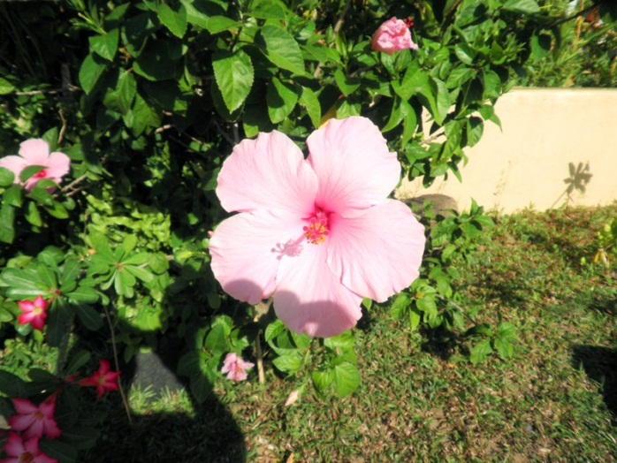

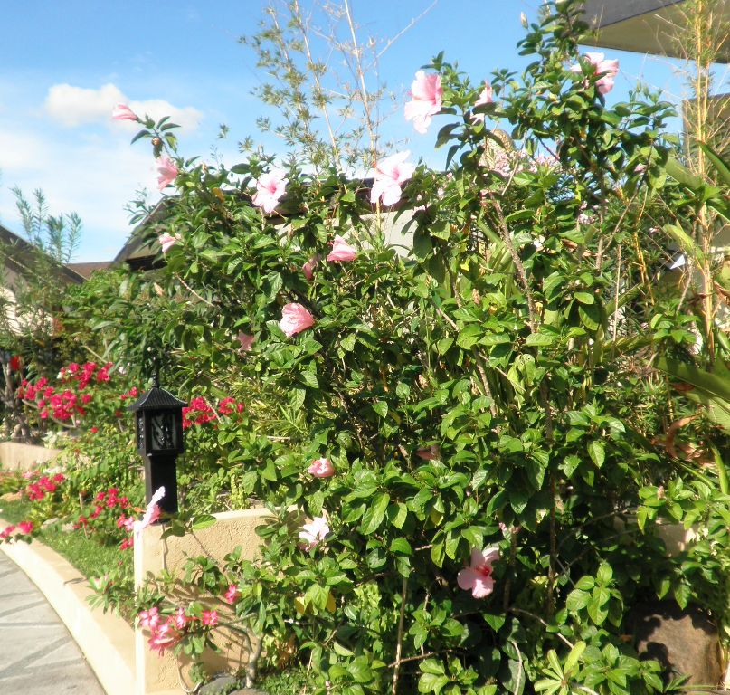

Sampaguita

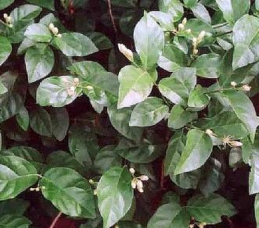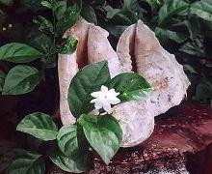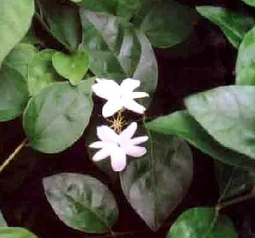

Santan

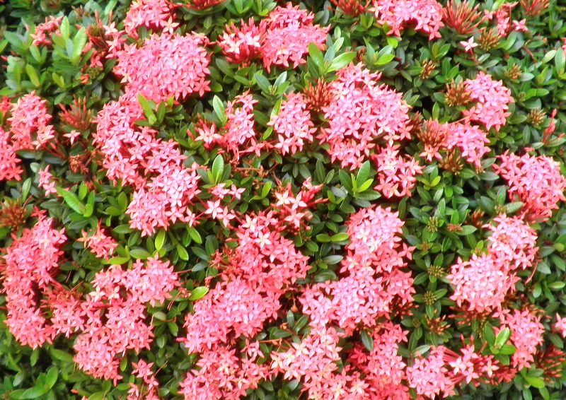

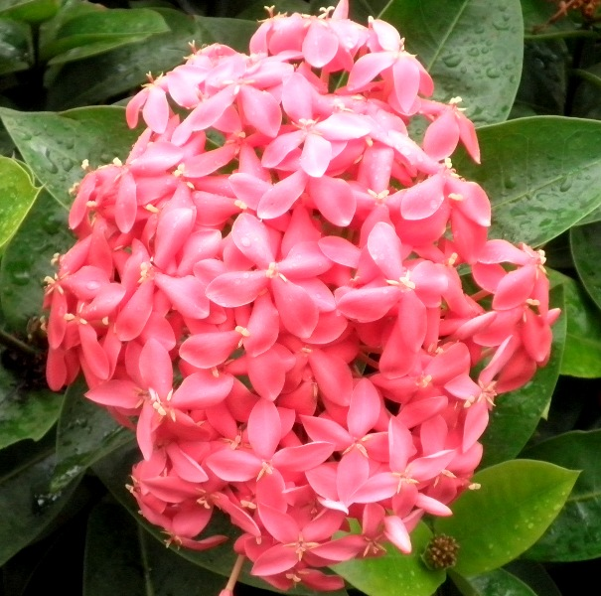

Animals (A) - Philippine Animals

Crested Serpent Eagle

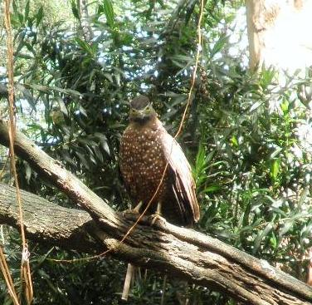

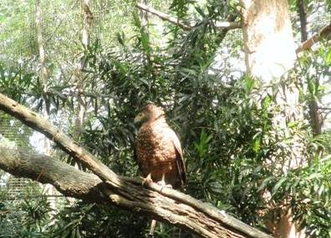

Philippine Brown Deer

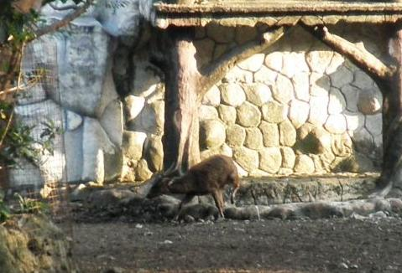

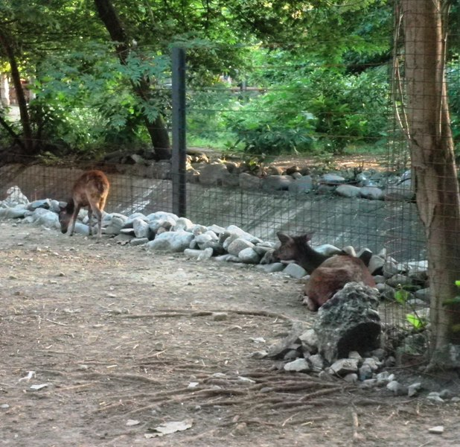

And Then Some (S) - A People’s Park and A Landmark Place

Rizal Park in Manila

Rizal Monument
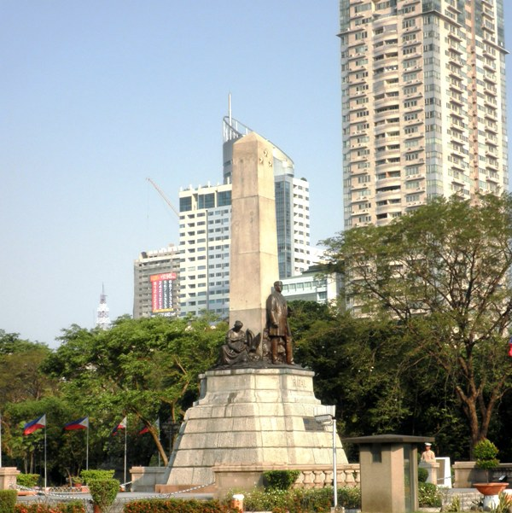

“The Martyrdom of Jose Rizal”
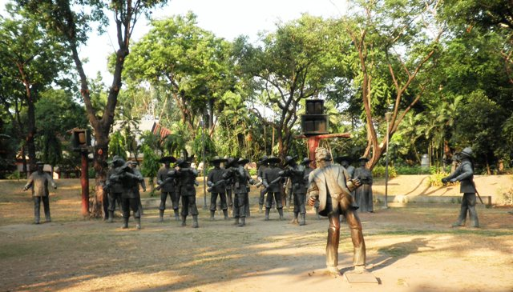

Jose Rizal Sculpture  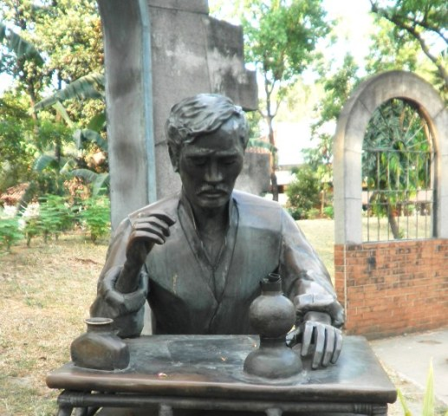 | Gallery of Heroes  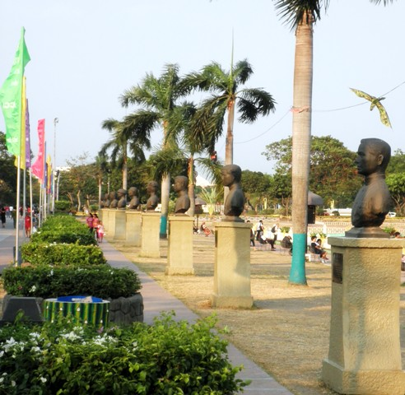
Gomburza Marker  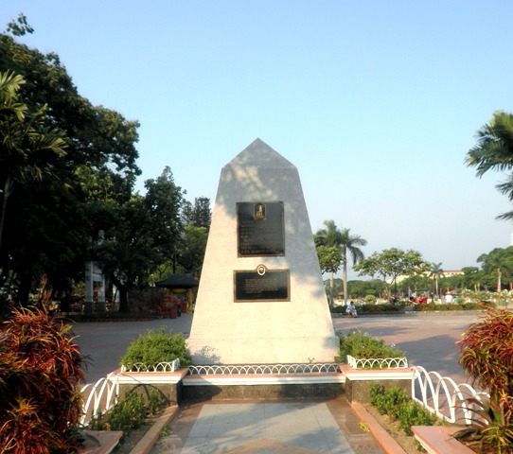 | Lapu-Lapu- Statue  