My Blog, My Philippines
In Pictures – Part I
By Alex Moises / Philippines, 2010-2011 Version / Dedicated to Gabby Moises
<People (PE), Places (PL), Nature (N), Animals (A), And Then Some (S)

People (PE) – Filipinos

Gabby and Alex Moises

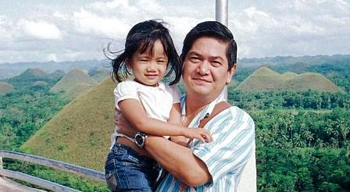

Gabby and Leticia Moises

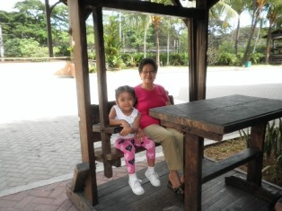

Andres Bonifacio and Corazon Aquino
(Photo Contributors: Bonifacio’s Photo, Courtesy of the National Library of the Philippines / Aquino’s Photo, Courtesy of the US Federal Government via Wikipedia)

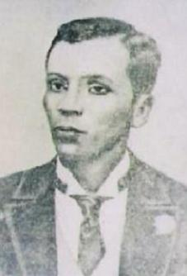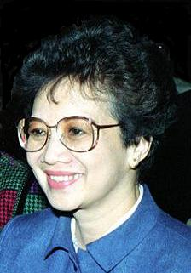

Efren “Bata” Reyes and Jose Rizal
(Photo Contributors: Reyes’s Photo, Courtesy of RailbirdJAM via Wikipedia / Rizal’s Photo, Courtesy of the National Library of the Philippines)

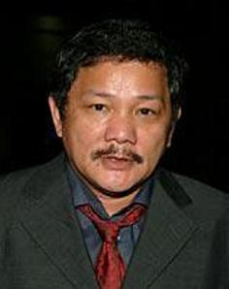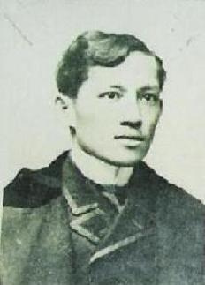

Manuel L. Quezon (second from right) and Family

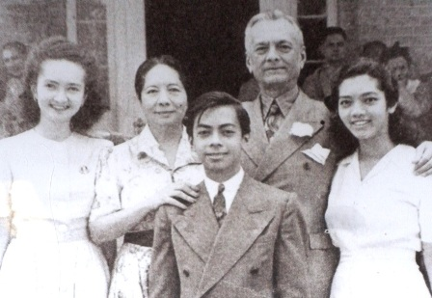

Places (PL) – Famous Places in the Philippines

Banaue Rice Terraces
(Photo Contributor: Photo in the Public Domain, Courtesy of “agricmarketing” via Wikipedia)

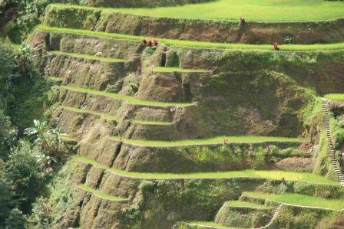

Chocolate Hills, Bohol

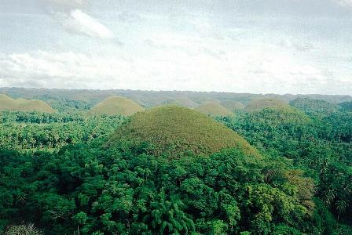

Corregidor Island

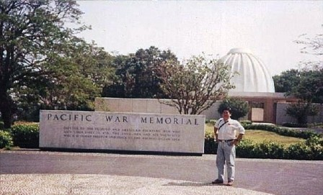

Fort Santiago, Manila

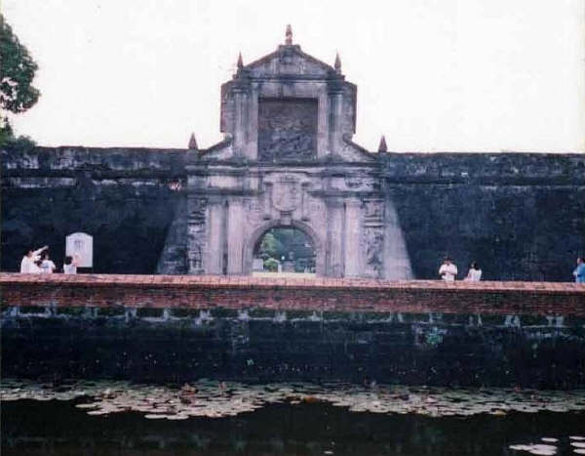

Quezon Memorial Tower at Quezon Circle in Quezon City

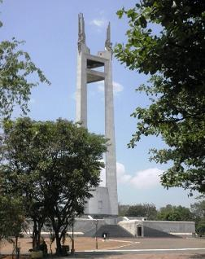

Rizal Monument at Rizal Park, Manila

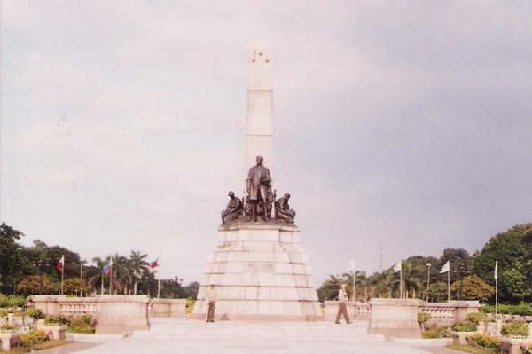

Subic

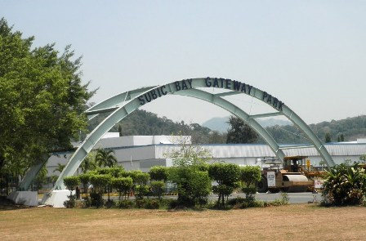

Nature (N) – Philippine Flowers

Bougainvillea

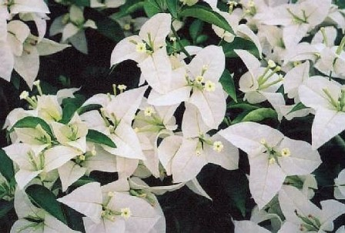

Dona Aurora

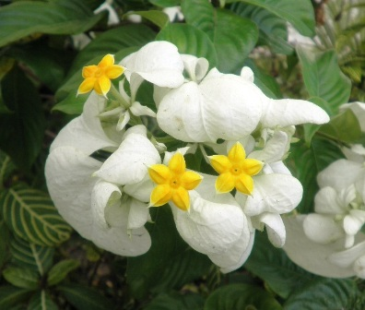

Gumamela - Hibiscus

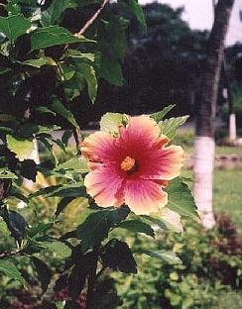

Sampaguita

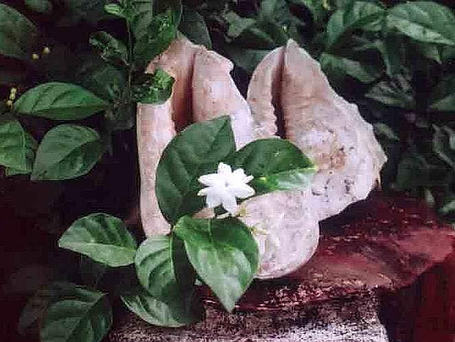

Santan

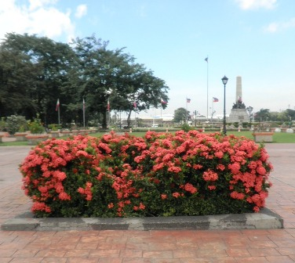

Yellow Bell

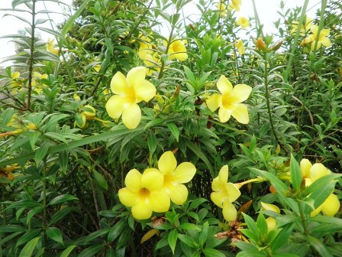

Animals (A) – Philippine Animals

Carabao
(Photo Contributor: Bob Martin)

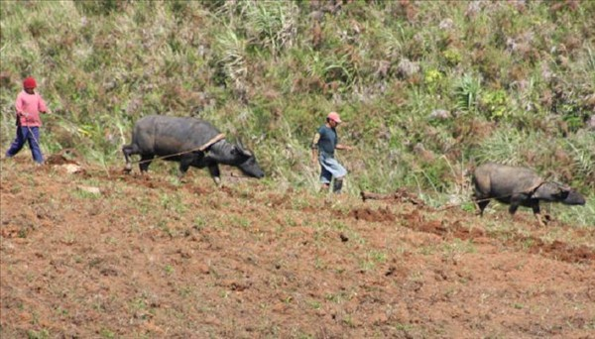

Philippine Eagle and Philippine Tarsier
(Photo Contributor: Eagle’s Photo, Courtesy of the Philippine Eagle Foundation)

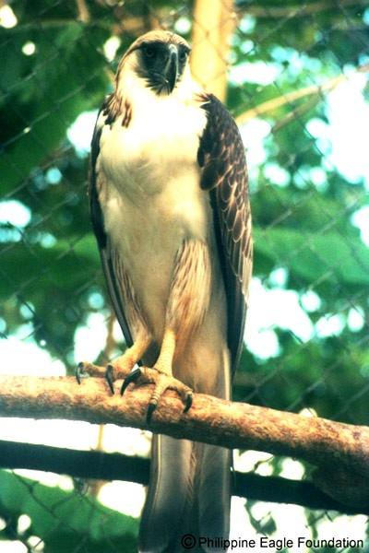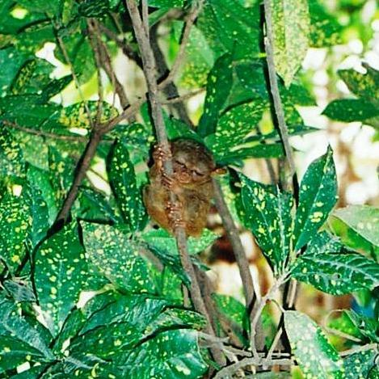

Visayan Spotted Deer
(Photo Contributor: “altaipanther” via Wikipedia)

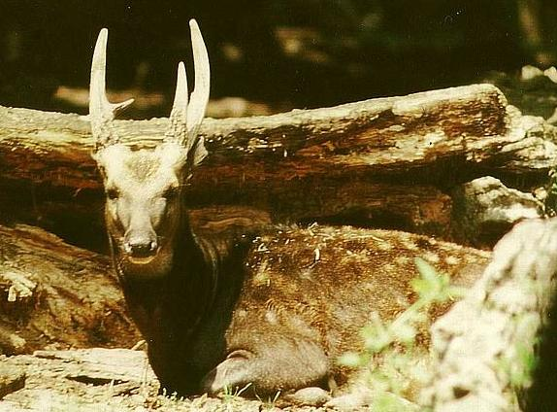

And Then Some (S) – Philippine Stamps

Left to Right: Manuel L. Quezon (1947), Special Delivery (1947) and Sampaguita (1948)

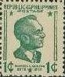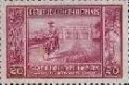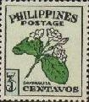

General Gregorio del Pilar (1949)

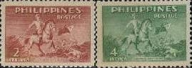

Orchids (1962)

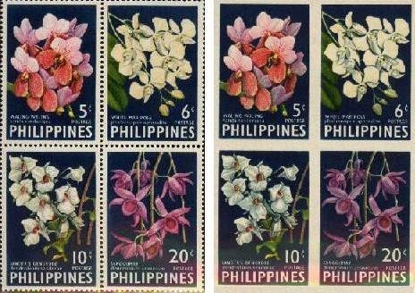

Tourist Spots (1971)

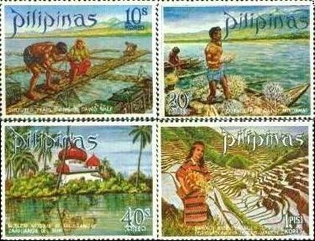

Rizal Monument at Rizal Park, Manila (1972)

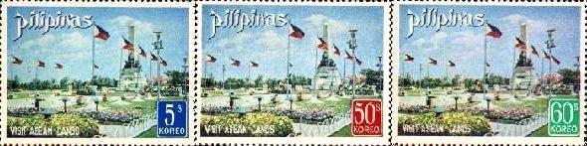

Andres Bonifacio Monument (1978) and Sipa Ballgame (1978)

